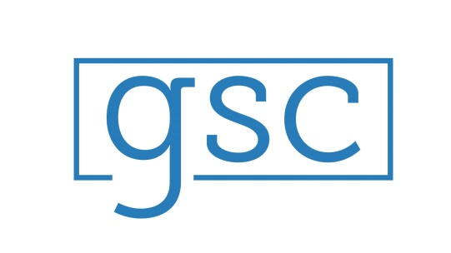
Greater Salisbury Committee
Revenue Cap Study

Background
In 1999, the Wicomico County Council voted to put into effect two significant tax hikes:
- A .46 cent property tax hike – a 23% increase over the previous year
- A 1% increase in the property transfer tax
As a direct result of these double tax hikes, a citizen led group known as VOICE (Voters Opposing Increased County/City Spending) was created. VOICE put together a grass roots effort to collect signatures to get a proposed Revenue Cap on the ballot in the election of 2000. They succeeded. The Revenue Cap was passed overwhelmingly by the voters of Wicomico County – 18,741 votes to 10,061 votes. The voters also overturned the 1% property transfer tax.
As a result of the election results of 2000, a Revenue Cap, which amended the County Charter and prohibits property tax revenue from increasing any more than 2% a year, has been the law of the land.
Today
GSC’s Observations:
- A huge percentage of the Wicomico County voting population was not of voting age when the Revenue Cap became the law of the land. Therefore an effort to educate the citizens about the Revenue Cap, and how it works, is appropriate and needed.
- Of those who are aware that Wicomico County has a Revenue Cap in place, we believe that very few people could explain the Cap “to their neighbors.” The Revenue Cap is difficult to explain, decipher, disseminate.
- A Revenue Cap is NOT a tax rate cap. We believe many people confuse the two.
- The Revenue Cap was a reaction to very bad legislating by the Wicomico County Council in 1999. It is hard to imagine ANY elected local body putting into place today what the Wicomico County Council put in place in 1999.
- There has been very little public discussion about the Revenue Cap since the first few years of its existence. We think public discussion about the Cap is a good idea.
- There has been a demonstrated fall in the performance and ranking indicators of our public school system since the Revenue Cap went into place.
- The Wicomico County Public School system is funded now, as it has been for some time, as a Maintenance of Effort school system. Translation: as a matter of public policy, Wicomico County funds its public school effort to the bare minimum that is required by state law. Is there a link to this MOE funding formula, and the Revenue Cap being in place?
- Wicomico’s elected officials proclaim that Wicomico County is a poor county. So, we believe it’s appropriate to ask: If Wicomico is a poor county, why does it have in place a funding formula that limits the revenue the County can take in.
- Revenue Caps are rare. Only one other Maryland County has one in place: Talbot. We think a fair question to ask is this: if Revenue Caps were such a good idea for limiting government spending, why wouldn’t more counties have them in place?
- Wicomico’s credit rating, from the credit agencies in NY, is very good. That said, those credit agencies have identified the Revenue Cap as being something that will prevent Wicomico County from attaining the top credit rating.

Moving Forward
GSC and BEACON have identified potential and serious unseen consequences that may await Wicomico County if the Revenue Cap stays exactly as it is. Therefore, the Revenue Cap committee submits the following as potential fixes for these unseen consequences:
- Change the language of the Cap to be able to take the higher of CPI-U or 2% each year
- Using a different inflation index (S&L IPD) instead of the CPI-U index
- Implement a safety valve which allows flexibility to cap limits in case of drastic economic changes. Typically this requires a majority vote either by the public or pre-determined board.
- Using homestead exemptions (save on taxes on a person’s home) or circuit breaker programs (benefits to taxpayers, with benefits increasing as incomes decline.)
- Implement a sunset/reset clause which will automatically terminate the Cap after a fixed time unless it is extended
- Elimination of the Revenue Cap? Implement a tax rate cap as an alternative.
Change the language of the cap to be able to take the higher of CPI-U or 2% each year

